**Practical 16☺:**

***Question:***

Develop a C program that simulates a matchstick game between the user and the computer. The objective of the game is to avoid picking the last matchstick. The program should ensure that the computer always wins by strategically picking matchsticks. The game starts with 21 matchsticks. The user and the computer take turns to pick 1, 2, 3, or 4 matchsticks. The player forced to pick the last matchstick loses the game. Rules: 1. The game starts with 21 matchsticks. 2. The user is asked to pick 1, 2, 3, or 4 matchsticks. 3. After the user picks, the computer makes its pick. 4. The player who is forced to pick the last matchstick loses the game

**Code:**

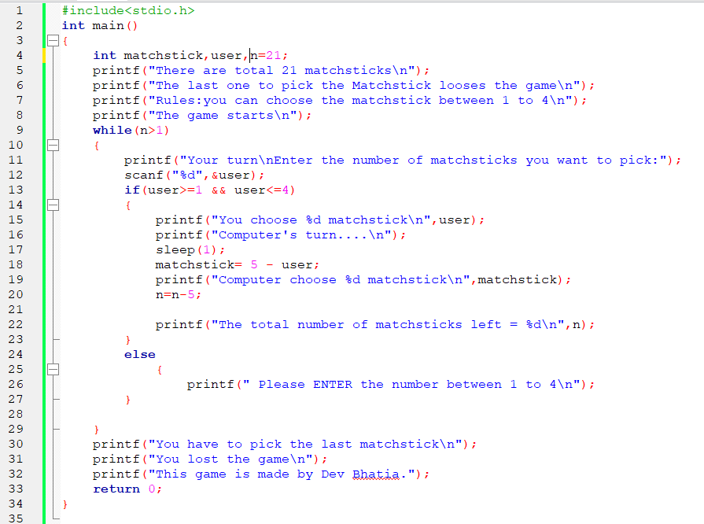

**Output:**

